Drive Action Contents

1. Raspberry Pi的功用
2. 感測器
3. Access Point
4. Database
5. Web Server (Apache, Flask)
6. Image Processing
7. 雲端硬碟 (Samba)
8. Raspberry Pi與自走車
9. Web Server服務前端php程式之自走車動作控制及影像串流要求
10. 自走車動作控制
11. 影像串流
12. 人臉偵測與自走車轉彎
13. 自走車動作控制之http命令**

FORWARD 🡪 <http://192.168.58.138:5000/forward>

BACKWARD 🡪 <http://192.168.58.138:5000/backward>

LEFT_then_STOP 🡪 <http://192.168.58.138:5000/left>_stop

LEFT_then_GO 🡪 <http://192.168.58.138:5000/left>_go

LEFT_ALWAYS 🡪 <http://192.168.58.138:5000/left>_always

RIGHT_then_STOP 🡪 <http://192.168.58.138:5000/right_stop>

RIGHT _then_GO 🡪 [http://192.168.58.138:5000/right](http://192.168.58.138:5000/right%20) _go

RIGHT _ALWAYS 🡪 [http://192.168.58.138:5000/right](http://192.168.58.138:5000/right%20) _always

STOP 🡪 <http://192.168.58.138:5000/stop>

**http命令之IP 位址是使用之 Raspberry Pi而定。

1. CAR1: Raspberry PI’s 電路板腳位與自走車動作控制邏輯電位

|  |  |  |  |  |  |
| --- | --- | --- | --- | --- | --- |
| 電路板腳位** | | 29 | 31 | 32 | 33 |
| L298N 輸入 | | IN1 | IN2 | IN3 | IN4 |
| L298N 輸出 | | OUT1 | OUT2 | OUT13 | OUT4 |
| 馬達腳位 | | 左上 | 左下 | 右下 | 右上 |
| 自走車  動作控制  邏輯電位  (0: 低電位，  1: 高電位) | 動作 | 邏輯電位 | | | |
| forward | 0 | 1 | 1 | 0 |
| backward | 1 | 0 | 0 | 1 |
| left_stop | 0 | 0 | 1 | 0 |
| 0 | 0 | 0 | 0 |
| left_go | 0 | 0 | 1 | 0 |
| 0 | 1 | 1 | 0 |
| left_always | 0 | 0 | 1 | 0 |
| right_stop | 0 | 1 | 0 | 0 |
| 0 | 0 | 0 | 0 |
| right_go | 0 | 1 | 0 | 0 |
| 0 | 1 | 1 | 0 |
| right_always | 0 | 1 | 0 | 0 |
| stop | 0 | 0 | 0 | 0 |

**Raspberry Pi 3’s 電路板腳位

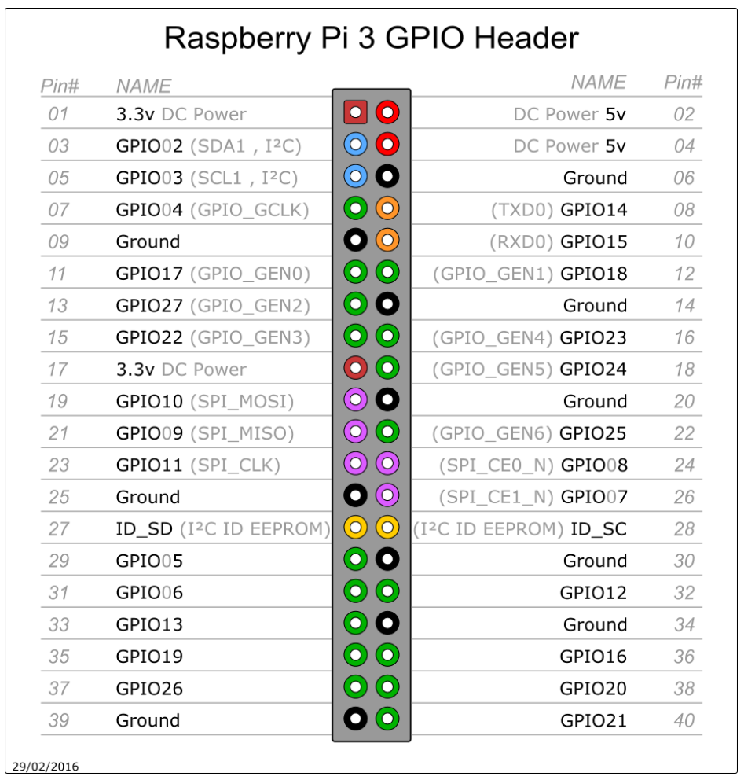

1. Python Code of Flask API: car1_bgyo_9actions_openCV.py
2. 自走車動作
3. 前進 (forward)
4. 後退 (backward)
5. 左轉後停止 (left_stop): 左轉0.2秒後停止
6. 左轉後前進 (left_go): 左轉0.2秒後前進
7. 持續左轉(left_always): 左轉打轉
8. 右轉後停止 (right_stop): 右轉0.2秒後停止
9. 右轉後前進 (right_go): 右轉0.2秒後前進
10. 持續右轉(right_always): 右轉打轉
11. 停止 (stop): 停止
12. 影像串流與人臉偵測